Squance digram :-

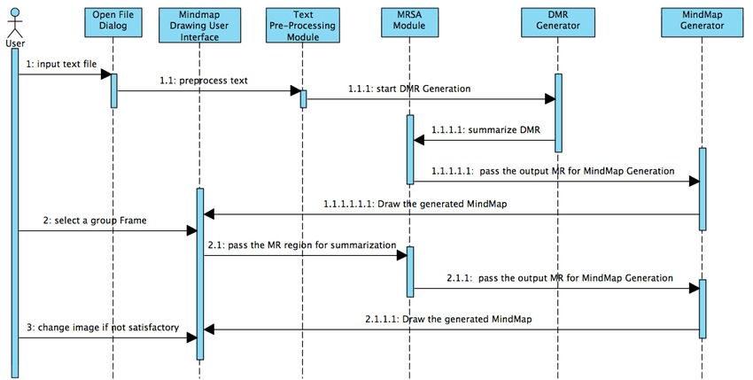

Intraction digram :-